Lab: Crypt - Ciphers
The Caeser Cipher is a way of encrypting a message. Start with the alphabet. Then, shift it left by some value N. Each letter is now encoded by its place in the alphabet. If you know the amount of the shift (N), you can decode the message using an opposite shift.
For example, if N is 5, then the alphabet:
a b c d e f g h I j k l m n o p q r s t u v w x y z
Becomes:
f g h i j k l m n o p q r s t u v w x y z a b c d e
A is encoded to F, B becomes G, and so on. Unfortunately, this cipher is not great. It’s easily cracked just by trying all 25 possible ways of shifting the alphabet to see which one produces a read-able output. It’s also possible to use frequency analysis – the practice of counting how many times each letter appears in the encrypted text. If you know that the letter E is the most common letter in English text, you can find the most common letter in the encrypted text and assume that it is the encrypted version of E. Once you’ve found E, you can immediately get every other letter!

Option 1: Random monoalphabet cipher
The Caesar cipher, which shifts all letters by a fixed amount, is ridiculously easy to crack—just try out all 25 possible keys. Here is a better idea. For the key, don't use numbers but words. Suppose the key word is FEATHER. First remove duplicate letters, yielding FEATHR, and append the other letters of the alphabet in reverse order. Now encrypt the letters as follows:
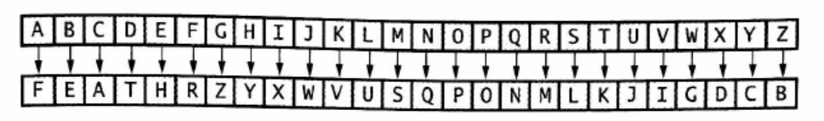
Option 2: Vigenere cipher
The trouble with a monoalphabetic cipher is that it can be easily broken by frequency analysis. The so-called Vigenere cipher overcomes this problem by encoding a letter into one of several cipher letters, depending on its position in the input document. Choose a keyword, for example TIGER. Then encode the first letter of the input text like this:
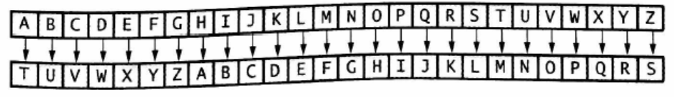
That is, the encoded alphabet is just the regular alphabet shifted to start at T, the first letter of the keyword TIGER. The second letter is encrypted according to the map:
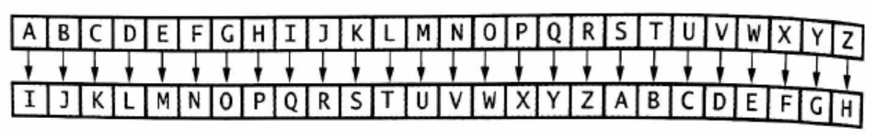
The third, fourth, and fifth letters in the input text are encrypted using the alphabet sequences beginning with characters G, E, and R, and so on. Because the key is only five letters long, the sixth letter of the input text is encrypted in the same way as the first.
Option 3: Playfair cipher
Another way of thwarting a simple letter frequency analysis of an encrypted text is to encrypt pairs of letters together. A simple scheme that was actually used during both World War 1 and 2 is the Playfair cipher. You pick a keyword and remove duplicate letters from it. Then you fill the keyword, and the remaining letters of the alphabet, into a 5 x 5 square. (Since there are only 25 squares, I and J are considered the same letter in this algorithm.) Here is such an arrangement with the keyword PLAYFAIR:
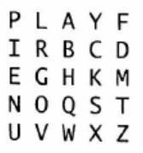
To encrypt a letter pair, say AT, look at the rectangle with corners A and T. The encoding of this pair is formed by looking at the other two corners of the rectangle—in this case, FQ. If both letters happen to be in the same row or column, such as GO, simply swap the two letters.
One tricky thing about the Playfair cipher is that the rules are a bit ambiguous. What do you do if the pair of letters to encode is the same letter? How do you handle I’s and J’s? What if there’s an odd number of letters (the last letter doesn’t have a pair)? In WW1 and 2, these were not big problems because a human being was encrypting and decrypting. For a computer, we’ll need to establish some rules. We’ll try to keep it simple:
  - For same-letter pairs, leave the letters exactly as they are. For example, EE will stay as EE
  - For I’s and J’s, encode them both to the same letter. When decoding, your document will contain I’s in place of J’s (this is ignored by my tester).
- If the document has an odd number of letters, add the letter J to the end of the document before encrypting, then use this J as the pair for the last character.

